Math Moments
April 2018

The Seven Math Processes
The curriculum identifies seven key processes students engage in as they learn and use math throughout the grade. Last month’s newsletter, focussed on problem solving, reasoning and proving and reflecting. This month’s focus will be on selecting tools and computational strategies and connecting. Your child will use these processes when learning new concepts and procedures, practising skills, and solving problems. Your child will also draw on his/her knowledge and skills from the five strands and make connections with real-life situations.
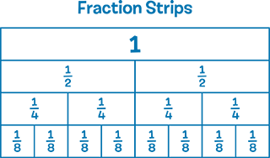
Selecting Tools and Computational Strategies
Tools used in math class include measuring tools such as rulers and protractors, physical manipulatives such as fraction strips, and digital learning tools such as graphing tools. Digital tools offer many ways to enhance learning by allowing students to see math unfold in ways that can’t happen with a physical
object. Such tools can be used to reduce the time spent on routine tasks and allow more time for concept development.
In your child’s math classroom, students:
- choose physical and digital learning tools and computational strategies to investigate, explore, represent, and solve problems
- use technology (tablets, computers, interactive whiteboards, etc.)
- use calculators for some tasks, but not for all tasks, depending on the goal of the lesson

Connecting
Students learn best when they can connect new concepts with what they already know, and connect mathematical ideas to real-world situations.
In your child’s math classroom, students:
- make connections between new knowledge and skills and prior learning
- make connections between math and other subjects

Taken from: Math Learning Today: produced in partnership with the Ministry of Education and Ontario District School Boards 2016

