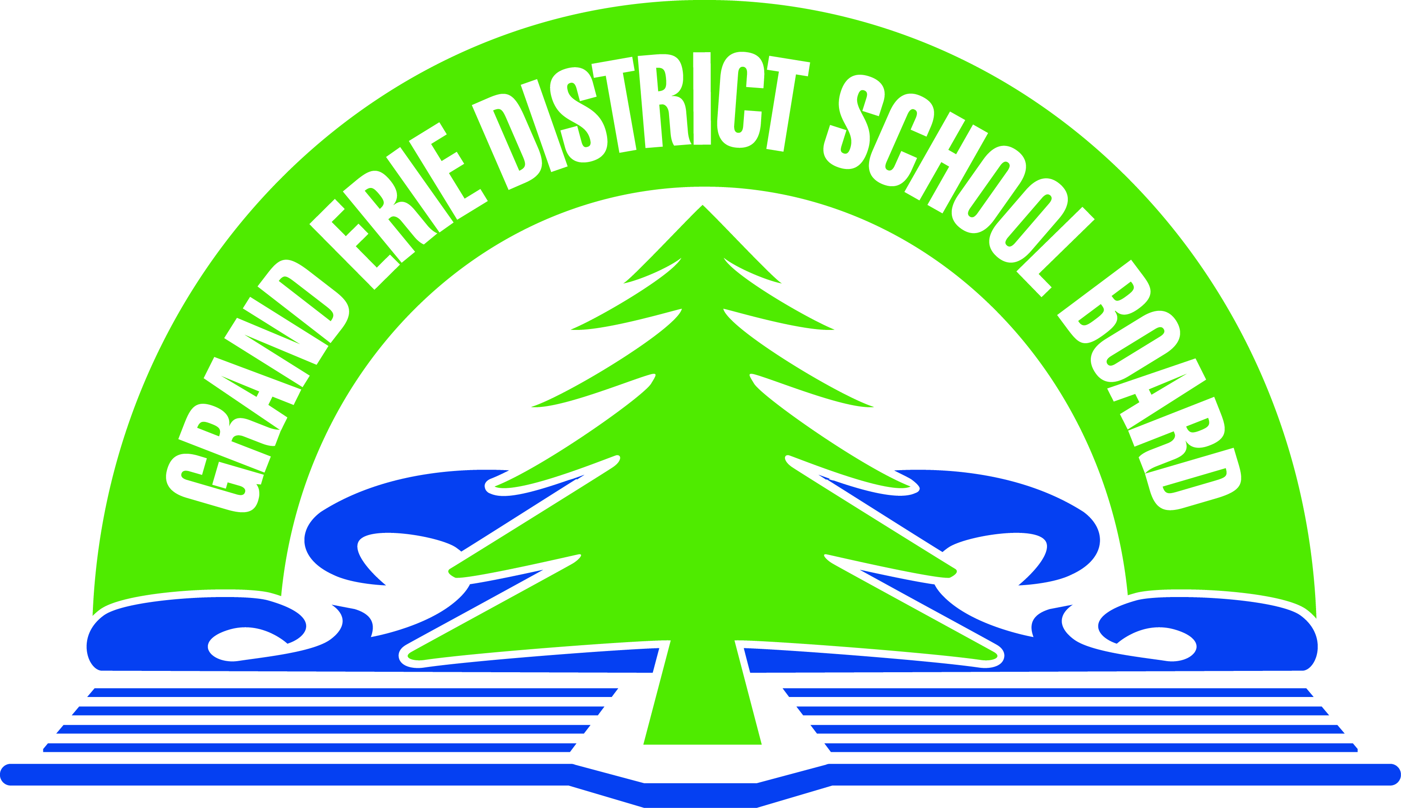

Distribution of Materials to Schools

- Please fill in our application form and attach the final print copy of your material to be approved, in one of the following formats: .pdf - .doc - .jpg - .rtf - .gif
- Please note that we require all materials 2 weeks prior to the date of your event
- Please ensure that you have completely filled out the application.
- You will be notified by email if approval is granted
- Please refer to Policy # SO4 for more information
- http://www.granderie.ca/Board/BylawsPoliciesProcedures/Policies.aspx

- Email or Send your completed application and sample to:

“Materials Distribution”
flyers@granderie.ca
Grand Erie District School Board
349 Erie Avenue, Brantford, ON N3T 5V3

Event Name:
(Name of event, activity etc.)
Organization Name:
Contact Name:
Email:
Contact Telephone #:
Address:
Non-Profit
Registration #
Intended Audience
(Brant/Brantford/Haldimand/ Norfolk)

Target Grade(s):

