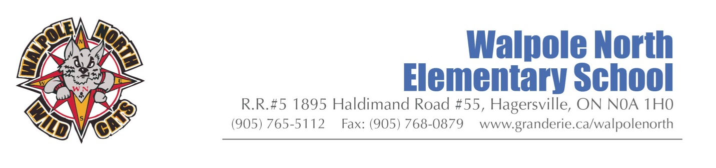

Walpole North Elementary School Council
Meeting Minutes- September 29, 6:00 pm
Attending: Randy Ongena, Lorelei Parsons, Heather Martin, Alisha Fernandes, Amanda Richardson, Starr Phibbs, Kristy Johnson
Regrets: Debbie Awalt
Principal Update & Introduction- Mr. Ongena
- Sharing 2020-21 Grand Erie School Council Guide
- Multi-Year Plan
- Organization & Enrollment Update
We have 200 students in our 11 classrooms currently and 35 students in the Virtual Learning Academy.
- Meet the Teacher Update *Virtual through D2L – Staff will do a welcome to my room video that will be uploaded Wednesday Oct 7.
- Nutrition Program Update- We are starting the nutrition program this week with “grab and go” type of snacks. They will be delivered to each class in a sanitized bin.
- School Updates:

School Council Elections: Elections are to take place within the first 30 days of the school year.

Current:
- Chair/ Co-Chair: Chair- Amanda Richardson, Co-Chair – Alisha Fernandes
- Secretary: - shared.

- School Council Budget Update –
Finances- Thanks to JLM Metal Recycling who has donated the proceeds from the metal recycling bin. We have earned $761.10 and now only have a deficit of $12.34 for the playground equipment.
Our Hot Lunch Program is at $2,238.64
Parents of Walpole- Fundraising is at $3,338.31.

- New Business
- Monthly recognition of student achievement will begin at the end of October.
- Nutritional Program Co-ordinator: - Lisa Lickers
- Education Week- virtual event?- Special events? Activities that can be shared on D2L?
- Set next meeting dates (Minimum 4 per year)
Tuesday November 10, 2020
- Motioned by Alisha Fernandes and second by Amanda Richardson $100 to go to each classroom for supplies.
- Motioned by Alisha Fernandes and second by Amanda Richardson- Any money owing after donations/ reaching out to business for the Nutrition totes to be covered by parent council.
School Councils Resources

- There has been no direction from the Ministry of Education to pause School Councils. So, they can move ahead.
  - Meetings can be held virtually. Elections can be done this way as well.

- Note: all fundraising activities are on hold right now due to COVID-19. This decision will be revisited later this year by Senior Administration.

- The School Council section of our website has been updated: https://www.granderie.ca/board/parentportal/school-councils

- Find the 2020-21 School Council Guide here: https://www.granderie.ca/application/files/4816/0037/9581/School_Council_Guide_2020.pdf
Please share the guide with your School Council.
You can also find Grand Erie’s Policy on School Councils here: http://granderie.ca/application/files/6515/0102/0744/SO2_school_councils.pdf.

