TAYLOR ROBERTSON – WOODVIEW EDT STAFF
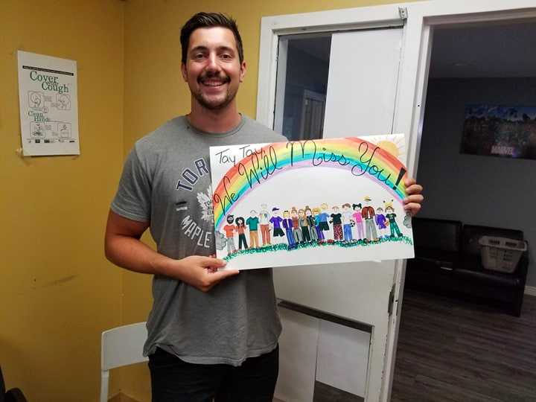

My name is Taylor Robertson and my role within the classroom will be to ensure that our learning center will be a safe space where all youth can learn, grow and feel supported throughout the school day. My team and I will work through a strength-focused lens to help develop positive & therapeutic relationships within the classroom.
About me!!!
I have been working with a wide variety of different youth for approximately the last six years. My experiences have varied from daycares and summer camps to residential living and classrooms within the HWDSB. This year has been filled with many new events for me as I have recently just bought my first house, I am now recently engaged to my fiancé Amanda and now I will be stepping into a new position within the Woodview program. I am very excited to see what this school year has in store and I am confident we will have a positive year together within the classroom!
Interests & Hobbies
Pokémon, Football, Impressions, Beat Boxing, Soccer, Fitness, Art, Video Games, Basketball, Music (playing and listening), Comedy

TYLER BEEDHAM – EDT PROGRAM COODINATOR
My name is Tyler Beedham, I am the program coordinator at the elementary day treatment program. I have worked in mental health for the last 11 years. Working at Lansdowne, Canadian Deaf Blind Association, Lynwood Charlton Centre and last year I made my way to my current role with Woodview in collaboration with the GEDSB.
I love playing sports namely soccer, running and combat sports. I enjoy hiking, travelling and trying not to take life too seriously. I have a 2 year old son at home and love my job at Woodview! I had the pleasure of getting to know all the students over the summer and look forward to bringing that positivity into the Classroom setting!
Phone: 519-752-5308 ext.946
Email: tbeedham@woodview.ca

CHRISTINE DRAGOJLOVICH – CLINICAL MANAGER
My name is Christine Dragojlovich and I am very excited to be part of this wonderful school program that all of your children are participating in! I have had the honour of working at Woodview for 17 years and I absolutely love my job!
I have an amazing husband, three beautiful sons and an incredible daughter and I learn from all of them each and every day!
I love the colour pink and really enjoy being outdoors in nature and swimming.
I hope that your children have a fabulous year with us!
Please feel free to contact any of us anytime!
Phone: 519-752-5308 ext. 113
Email: cdragojlovich@woodview.ca

PENNY TELFER – EDT CLASSROOM TEACHER (ON TEMPORARY LEAVE)
Hello everyone! I cannot wait to get back into the classroom to be with our amazing students again this fall. My hip replacement surgery went well this summer and I hope to be back around Thanksgiving time.
My heart for teaching began a long time ago, but after my own three children were in school full time I returned to school myself to realize my career goals. I have been teaching for 17 years, with 10 of those years being in self-contained special education classes. Most of my additional qualifications training as well as professional workshops, conferences and readings focus on special education needs and issues .
As I mentioned, my husband and I have three children; a daughter and two sons, who are now all grown up and on their own. We also have three grandchildren – two girls and a boy – and are expecting our fourth in October. We love being grandparents! I especially love making knitted and crocheted items for my family or spending time at our cottage with them.
I’m looking forward to getting back to the classroom as soon as possible. I hope that I can pop in every once in a while to keep my presence known so that it won’t be too difficult a transition when I return.
Should you need to contact me in the meantime, I am still available. If you were with us last year, you can still use the Remind app. Otherwise, use my email address: penny.telfer@granderie.ca
See you soon!

Classroom Staff 2019-2020 Administration
Woodview Grand-Erie Woodview Grand-Erie
Tyler Beedham Mike Vanka Christine Dragojlovich George Nurse
Taylor Robertson Penny Telfer
Kiera Roberts (Mohawk Student)
Kiera is a second year Mohawk student who will be joining the staff Tues.-Fri. until Mid-Dec./19

