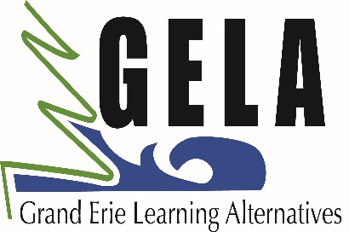
SUMMER SCHOOL 2018
Attention all Grade 8 Students
Get a high school credit over the summer!

• You could be involved in a drama presentation this summer!
• Do a high school art course this summer.
• Maybe you want to learn more about computers.
- Learn about how to pursue your personal goals or,
• Try a high school course that you can take from home on your computer.

Grand Erie is offering ‘Reach-Ahead’ credits for Grade 8 Students

The Grand Erie District School Board is offering Grade 8 students the opportunity to attend Summer School and acquire a Secondary School credit.

This is a great opportunity! If you struggle picking between Art and Drama, or you watched a brother or sister try to fit in music, gym, and French all into their timetable in grade 10, taking a course over the summer and getting a credit before you start high school will certainly be helpful!

Talk with your friends! Bring a friend or make new friends! Going to Summer School to get a leg up makes good sense!

If numbers permit, courses will run July 3 - 27, 2018
8:00 a.m. to 2:15 p.m. at Brantford Collegiate Institute and
Hagersville Secondary

Students may earn 1.0 credit via one of the following subjects:
BTT1O - Introduction to Business Technology
AVI1O - Visual Arts
ADA1O - Dramatic Arts
CHV2O & GLC2O – Civics and Careers (2 weeks each; 0.5 credits each)
(via eLearning as well: CHV2OV & GLC2OV - Civics & Careers)
PAL1O – Healthy Active Living

Please see your teacher and/or Learning Resource Teacher for more information. Please complete forms from www.granderie.ca and register through your elementary school.
Important: Deadline for registration is June 28, 2018
Contact: Carolyn Kelley, Summer School Secretary, 519-753-6079 x277012
carolyn.kelley@granderie.ca

