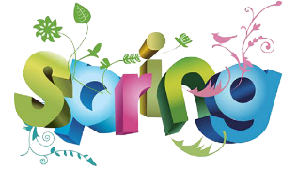
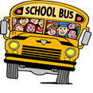
Oneida Central Public School
April 2022
Monday Tuesday Wednesday Thursday Friday
Upcoming Dates for May  Kindergarten Registrations – ongoing for birth year 2018  May 23rd - Holiday No school for students  May 24 – start of EQAO  May 16-20 – Book Fair |  |  |  | 1 Day 4  Wacky Hair Day
4 Day 5  **Reminder the Garden Centre Fundraiser closes on Thursday | 5 Day 1 | 6 Day 2 | 7 Day 3  McDonalds | 8 Day 4  BLACK & RED Day
11 Day 5  Purdy’s Fundraiser Delivery | 12 Day 1 | 13 Day 2 | 14 Day 3  Personalized Catering | 15  Good Friday  No School for Students
18  Easter Monday  No School for Students | 19 Day 4 | 20 Day 5 | 21 Day 1 | 22  Earth Day  PD DAY no School
25 Day 2 | 26 Day 3 | 27 Day 4 | 28 Day 5  Personalized Catering | 29 Day 1  Hat Day

