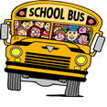
Oneida Central Public School
February 2021
Monday Tuesday Wednesday Thursday Friday
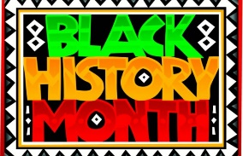 | 1 Day 2  Aboriginal Map Day  Grades K-3 | 2 Day 3  Popcorn Day | 3 Day 4 | 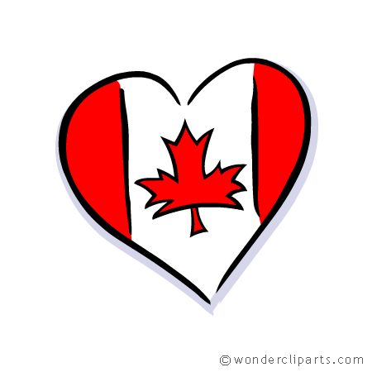  4 Day 5  Wear your Canadian attire/colours
7 Day 1  Report Cards Go Home | 8 Day 2 | 9 Day 3  Popcorn Day | 10 Day 4  Aboriginal Map Day  Grades 4-8  McDonalds Hot Lunch | 11 Day 5
14 Day 1  Valentines Day  Wear Red, White and Pink | 15 Day 2 | 16 Day 3  Popcorn Day | 17 Day 4  Personalized Catering Hot Lunch | 18 Day 5
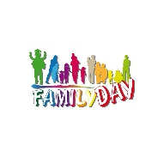  21 No School  FAMILY Day  Have FUN!!! | 22 Day 1 | 23 Day 2  Popcorn Day  Pink Shirt Day | 24 Day 3  Personalized Catering Hot Lunch | 25 Day 4
28 Day 5 | Kindergarten Registrations have started.  If you have or know a child born in 2018, please visit www.granderie.ca or call the school!  905-765-4700 |  | Upcoming Dates for March  March 1st – Parent Council Meeting 6pm  March 14th-19th – March Break

In Mid-January, Oneida Central School began a school-wide Indigenous Inquiry Project that sprung from the Land Acknowledgement read each morning during announcements. Our question was, “If we acknowledge and give gratitude to the Haudenosaunee and Anishinaabe people every morning, who are the Haudenosaunee and Anishinaabe people?” Classes have explored the question at their own age appropriate level, and posted their own questions or learnings on a bulletin board in the hallway. It is very interesting to see the baseline of our understandings and the directions that questions are taking us in.
In February, a gym-sized Map of Canada will come to Oneida Central to support our indigenous learning. Each class will be lead in grade appropriate investigation of the map of Canada, through an indigenous lens. We are pleased to be able to bring this hands-on style of learning to Oneida.
Attached are two videos for parents to view so you are able to envision and discuss the Map experience with your child(ren) once you’ve seen it in action.

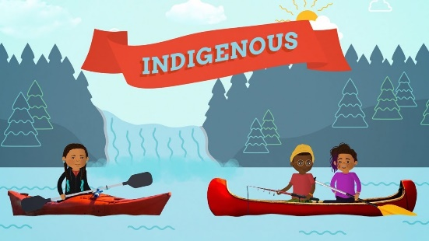 | The word Indigenous - explained l CBC Kids News  Indigenous people are the first people to live in a place. In Canada, Indigenous people belong to a number of different communities or nations. CBC Kids News...  youtu.be

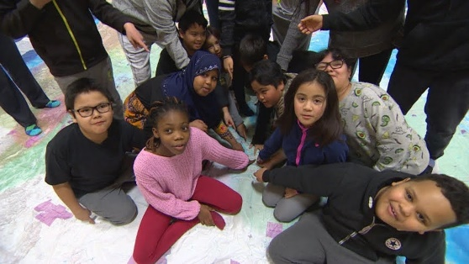 | Giant Indigenous Peoples Atlas floor map gives students a new perspective on Canada  A giant floor map based on the Indigenous Peoples Atlas of Canada has been travelling the country, giving educators and students a chance to take a different...  youtu.be

