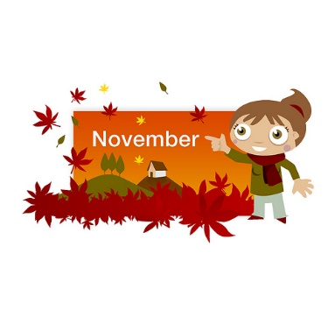
Oneida Central Public School
November 2021
Monday Tuesday Wednesday Thursday Friday
1 Day 3  Dielman Fundraiser begins today and runs until November 12th | 2 Day 4 | 3 Day 5 | 4 Day 1 | 5 Day 2  PLAID SHIRT Day  Report cards sent home
8 Day 3  Virtual Book Fair  November 8-15th | 9 Day 4 | 10 Day 5 | 11 Day 1  Personalized Catering Hot Lunch  Remembrance Day  Parent Interviews | 12 PD DAY  Last day to order Dielman fundraiser  Parent Interviews
15 Day 2  Fresh from the Farm Delivery  12-3pm | 16 Day 3  Parent Council  Meeting 6PM | 17 Day 4  Popcorn  Day | 18 Day 5  McDonalds  Hot Lunch | 19 Day 1  NEON Day
22 Day 2 | 23 Day 3 | 24 Day 4  Popcorn  Day | 25 Day 5  Picture Retake  Day | 26 Day 1
29 Day 2 | 30 Day 3 | Upcoming Dates:  December 16th – Holiday Turkey Dinner  December 20th – Christmas Holidays begin  January 3rd – Welcome back to School 2022

