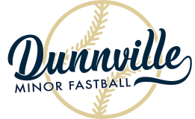
DUNNVILLE MINOR FASTBALL
c/o 144 Fairview Ave East, Dunnville, Ontario N1A 1B1
www.dunnvilleminorfastball.com
HOUSE LEAGUE REGISTRATION FORM
Office Use Only:  Please Print Clearly in Pen |  |  |  |  |  | CASH CHEQUE AMOUNT: _______  JUMPSTART ON#: _________________
Male  Female |  | Date of Birth:  Year: Month: Day: |  |  |  |  | T-Shirt Size: adult youth  XS S M L XL
Name:
Address:
City: Postal Code:
Landline: |  |  |  | Cellphone:
Parent(s)/Guardian(s):
Email:
Allergies / Health Concerns:
First Time  Player | Previous Pitching Experience |  | Previous Back Catching Experience |  | I have read Rowans Law
Before signing this form, please check the box that you and your child have read ROWANS LAW @
www.dunnvilleminorfastball.com
Please check the box if your child is unable to play on the Sunday following the civic holiday in August
Special requests will be considered and may be honoured only if team and/or division parity can be maintained. Only one request per player.
Same Team as Sibling - Name: _________________________________________________________
Play with a Buddy (applies to TBALL Division ONLY) - Name: ______________________________
How did you hear about DMF registrations?
WEBSITE EMAIL SCHOOL / ADVERTISING FLYER OTHER
LIABILITY WAIVER & PARENT/GUARDIAN CONSENT
As parent/legal guardian of the above named child, I hereby give my consent and approval to his/her participation in any and all activities of Dunnville Minor Fastball for the current year. I agree that Dunnville Minor Fastball, its agents, volunteers, administrators, sponsors, coaches, managers, umpires and assigns shall be relieved of all responsibility and not held liable in case of accident or injury. I understand that this activity is governed by rules and regulations which are designed for the safety and protection of its participants, and I agree that my child and family members will abide by “Policy 2014-02: Public Conduct on Haldimand County Property”. I hereby undertake to ensure that the above named child understands and abides by all such rules and regulations. I also understand that this activity requires a minimum of fitness for safe participation. I also give permission to allow the above named child’s picture, including their team picture, to appear on the Dunnville Minor Fastball website or other Dunnville Minor Fastball promotion.
I certify that I have read all the terms and conditions of this waiver and do intend to be legally bound thereby.

_____________________________________________________ __________________________________
Signature of Parent/Guardian Date

Dunnville Minor Fastball is run by volunteers. Are you interested in helping us?

COACH ASSISTANT COACH EXECUTIVE MEMBER
UMPIRE CANTEEN HELPER TRAVEL TEAM COACH

Name & Phone Number/Email Address: __________________________________________________
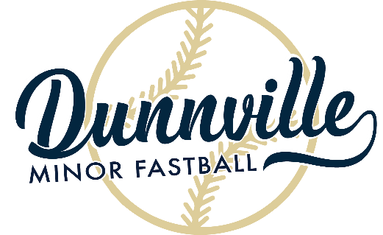
Registration 2024

Buckner’s Source for Sports
151 Queen Street, Dunnville
Any day during regular business hours with Buckner’s staff up to April 6th, 2024

DIVISION | BIRTH YEAR | REGISTRATION FEE – EARLY BIRD. BEFORE MARCH 3RD | REGISTRATION FEE
TBALL | 2020/2019 | $95 | $115
TYKE | 2018/2017/2016 | $110 | $130
MITE | 2015/2014/2013/2012 | $130 | $150
NOVICE | 2011/2010/2009/2008 | $130 | $150

ALL PLAYERS REGISTERED WITH DUNNVILLE MINOR FASTBALL MUST ABIDE BY THE FOLLOWING RULES:
- A HELMET WITH A FACE MASK AND A GLOVE ARE MANDATORY AND MUST BE SUPPLIED BY THE INDIVIDUAL PLAYER IN EVERY DIVISION. HELMETS MUST BE WORN WITH CHINSTRAP DONE UP.
- PROPER RUNNING SHOES OR BALL CLEATS MUST BE WORN (ABSOLUTELY NO SANDALS).
- ABSOLUTELY NO JEWELLERY ON THE BALLFIELD (MEDICAL ALERT EXEMPT).
- NO FOUL LANGUAGE OR INAPPROPRIATE BEHAVIOUR.
- TREAT UMPIRES, PLAYERS, COACHES, AND SPECTATORS WITH RESPECT.
- SMOKING OR CONSUMING ALCOHOL IS NOT PERMITTED ON COUNTY PROPERTY
- PLAYERS, FAMILY MEMBERS, SPECTATORS, AND VOLUNTEERS WILL ABIDE BY HALDIMAND COUNTY POLICY “2014-02: PUBLIC CONDUCT ON HALDIMAND COUNTY PROPERTY”.

* Divisions and/or age groups may change depending on final registration numbersEarly bird registration capped at $300 per immediate family when paid in full before March 3RD 2024 Registration capped at $350 per immediate family when paid in full before April 6th, 2024 NOTE: Financial assistance may be available through Jumpstart for those who qualify
REGISTRATION DEADLINE IS APRIL 6TH, 2024
www.dunnvilleminorfastball.com

