Progressive Discipline
Progressive Discipline Plan
Progressive discipline is a whole school approach. It utilizes a continuum of interventions, supports
and consequences to address inappropriate student behaviour and to build upon strategies that promote positive behaviours. When inappropriate behaviour occurs, disciplinary measures are applied within a framework that shifts focus from one that is solely punitive to one that is corrective and supportive.
Prevention and Intervention
Prevention and early intervention are essential in maintaining a positive school environment in which students can learn? Opportunities for students to learn from the choices they make, address inappropriate behaviours/attitudes and work with the team members at the school, who are dedicated to their support, are ongoing. This process also informs parents bringing to their attention awareness of the situation and asking for their supportive involvement.

Strategies include:
- All students are taught classroom rules and School Code of Conduct
- Bullying prevention program is taught to students
- Character education traits are taught and modeled by staff and students
- Students are given a chance to practice and review rules to ensure they understand them
When addressing inappropriate student behaviours or attitudes, consideration is given to the
particular students involved and the circumstances of the behaviour or attitude, the nature and severity of the behaviour or attitude and the impact of the inappropriate behaviour or attitude on the school
climate. Disciplinary interventions, supports and consequences for students with special education
needs are considered in conjunction with the student's strengths, needs, goal and expectations as
outlined in the Individualized Education Plan.

Progressive Discipline Strategies
Level One – Teacher
- Warning to student with reminder of rules
- Opportunity for dialogue with teacher, educational assistant or any other staff to discuss incident
- Time out in designated Quiet Zone
- Apology
- Withdrawal of privileges or detention
- Contact with parents
Level Two - Principal & Resource Staff
- Withdrawal of special privileges
- Opportunity to dialogue with principal with regards to steps taken to date
- Contact parents
- Referral to resource team
- Development of an IEP for behaviour
- In-school suspension
- Student-based team meeting to develop action plan
- Alternate or shortened day
Level Three - School and Community Partners
- Referral to board support services
- Case Conference
- Restorative Justice Circles
- Involvement of Community Services
Level Four - Safe Schools Team Involvement
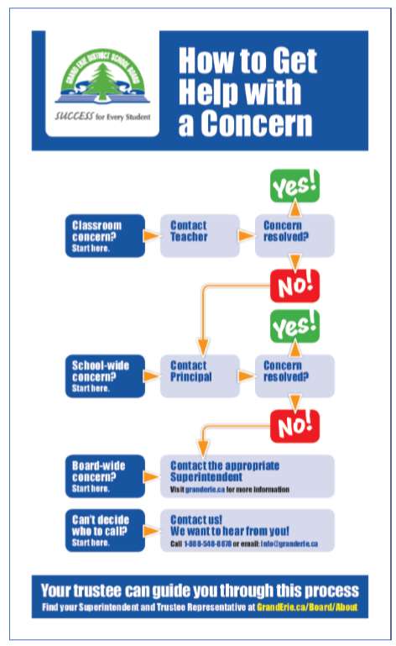
- Involvement of the Children’s Aid Society, School Resource Officer or alternative education opportunities
- Threat or Risk Assessment
- Out-of-school suspension or expulsion

