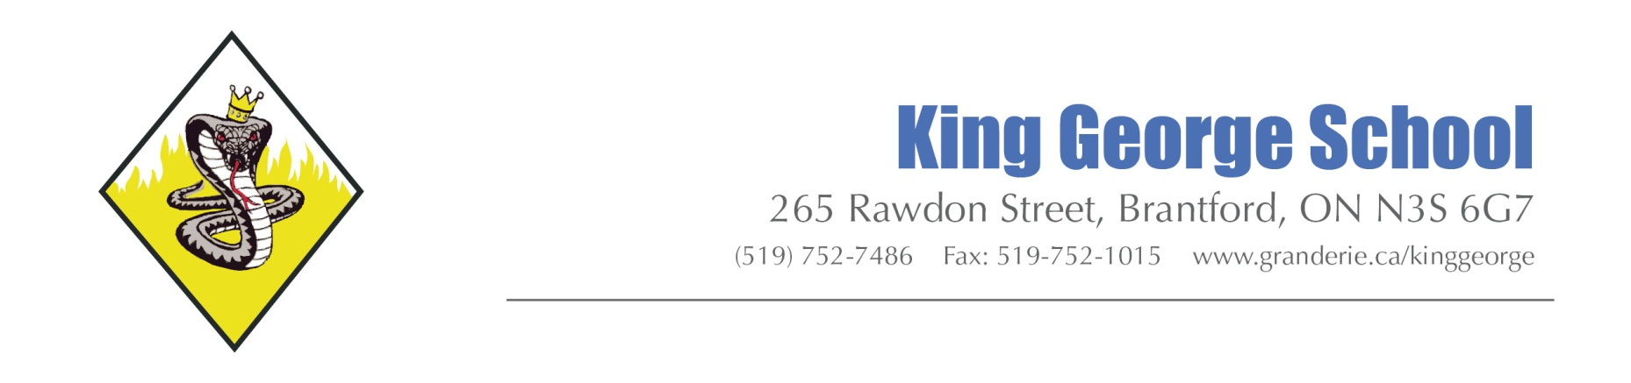

KING GEORGE IMPORTANT NOTICES TO PARENTS/CAREGIVERS
The following policies exist at King George School and are some of the most important to parents and visitors to the school. All policies are based on Grand Erie District School Board policies and are created to keep staff and students safe, focused on learning and free from distractions.

VISITORS TO THE SCHOOL
All visitors to King George School must check in with the main office. Items being dropped off for students can be left at the office and will be delivered to kids (if it is needed right away e.g indoor shoes, project), or students will be called to the office at a break (e.g. lunches, extra mittens etc.). In rare circumstances a parent may be invited to take a visitor sticker and head down to their child’s classroom or the child will be called immediately to the office (e.g. medication).
If a parent has important information for a teacher, they may choose to come to the main office before or after school and we can invite the teacher to come to meet you at the office.
No visitors can be in the halls of the school without having checked in at the office and been invited to take a visitor sticker / lanyard.

PLAYGROUND PICK UP AND DROP OFF
We welcome caring adults who wait with their children in the morning before the bell rings in the morning. Adults must remember that they may not enter the school from the playground doors. If you have cause to check in with the office, you must walk around the building to enter from the front doors where the office staff can monitor visitors.
Once the instructional day has begun it is necessary that adults are not on the playground before the dismissal bell at 3:10 pm. This includes recess times. The school grounds are a part of the Safe Schools space and we cannot have teachers who take their kids out side near the end of the day held responsible for dismissing early or asking adults to refrain from talking to students who may or may not be their own children. Please wait behind the fence until the bell rings.

CARING ADULTS AS POSITIVE ROLE MODELS
Making sure our kids have a positive environment for learning and growing is a shared responsibility. GEDSB Codes of Conduct outline responsibilities for staff, parents, visitors and students. Many KGS caring adults have made it clear that it is important to outline expectations for the caring adults who pick up and drop off kids at the school.
At King George it is expected that all adults in the community set a standard of interaction that creates a positive environment for students to grow and learn. This means that adults are expected to:
- Ensure your child(ren) arrive to school on time and attend school regularly. Please contact the school if they are going to be late or absent (voice mail is available 24 hours a day);
- Refrain from swearing and raising their voices at any other person while on or close to school grounds;
- Respect and follow all the By-Law signs regarding parking and stopping of vehicles (a map of these areas is attached);
- Respect and follow all the By-Law rules about smoking and vaping (No Smoking/Vaping within 20 metres of the school property);
- Respect and follow all of the school policies and support your child(ren) to do the same.

ELECTRONICS USE
Students are not allowed to have personal electronic devices visible during the school day. This includes recess while on school property.
At times a teacher may invite students to listen to music while working or use their devices for a specific reason. When this is directly supervised, teachers are able to determine their own acceptable use during each class.
AT NO TIME IS TEXTING, PHOTOGRAPHY OR POSTING ON SOCIAL MEDIA ALLOWED AT SCHOOL.
Parents are asked to respect and support this policy by making sure you call the school if you need a message sent to your child and redirect a child who might text you to say they are sick to go to the office and have office staff contact you. We are sensitive to rare occasions where a child may need to speak to a caring adult for sensitive reasons. In that case we still ask that students come to the office where a private space will be provided to the student so that they can contact their caring adult.

DRESS CODE
School Dress Codes are an important part of a healthy learning environment. Throughout the school year it is essential that all students follow the following dress code standards:
- Tank tops must have straps that are ‘two fingers wide’ and don’t show any bra straps and are thick enough material to not see a bra through it;
- Shorts/skirts must be longer than the longest finger when the student puts their hand at their side;
- No skin must be showing between the bottom of the shorts/skirt and the shoulder strap of the shirt.
- Logos and sayings on clothing must be appropriate for an elementary school (as determined by the staff of the school) this includes no alcohol, smoking, weapons etc. and all words must be respectful.
Students will be expected to change if they arrive at school and are not complying with the dress code.

SCHOOL CASH ONLINE
Every year money brought to school to pay for pizza, trips or other items gets lost. The best way to know that your money is making its way to the school is to pay online! We are attaching the instructions to register your child(ren) for School Cash Online for all of your fundraising, trips or other events that cost families a little extra. If you need help registering for this program, please call Jackie in the office (mornings only).

