MARCH 2019
Sunday | Monday | Tuesday | Wednesday | Thursday | Friday | Saturday
 | HOT LUNCH MUST BE ORDERED A MONTH IN ADVANCE BY CASHLESS |  | Snack Program is the first nutrition break of every Mon., Wed. & Thurs. Thank you to our volunteers | We are Zone 1 for Inclement Weather | 1 Panzerotti  Spirit Day – Hat Day  4/5FI & 5B Skating 1:30-3pm  Int Boys Basketball Tournament - SCS | 2
3 | 4  Alt date Int Boys Basketball Tournament - SCS  LPC Mtg @ 6:00 | 5 Pizza Day | 6  Cage Basketball - SCS  Grade 8 & SK Grad Photos in Music Room | 7 | 8 M’s  Spirit Colour – Green & White Day  11:10-Lakewood’s Got Talent  4 4/5  Skating 1:30-3pm | 9
10 | 11 | 12 | 13 | 14 | 15 | 16
17 | 18 | 19 Pizza Day  7A Dover Cliffs 2-3pm | 20  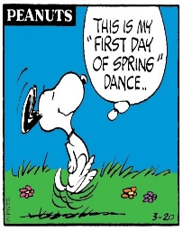 | 21 | 22 Chicken nuggets  Spirit Colour | 23
24/31 | 25 | 26 Pizza Day | 27 | 28  Can-con 1:30 in Gym | 29 Pita Pit  Spirit Colour | 30
CASHLESS ONLINE: www.schoolcashonline.com to register
M A R C H B R E A K

