What’s Up in Grade 4/5?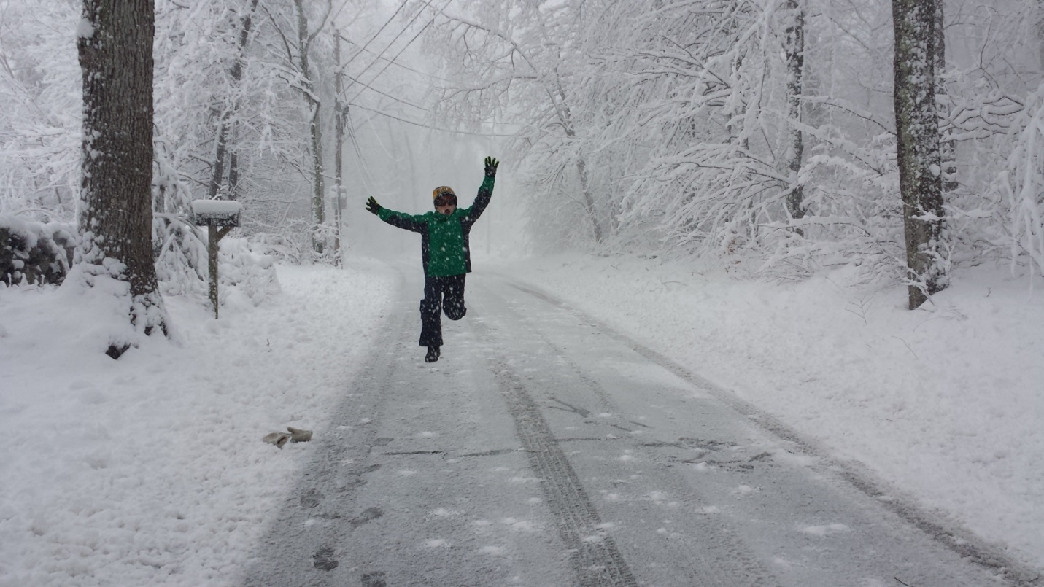
Happy February everyone!
With winter in full swing, and the class racing through a busy January, I felt it important to reconnect via the newsletter and give everyone an update as to what has happened and will be happening in Room 7.
In Mathematics, we had the pleasure of welcoming Mr. Michael Fuss into our room for the better part of three weeks, to learn about Measurement and Perimeter. Mr. Fuss is one of the Grand Erie Math Coaches, and he exposed us to a new math program called MathUp, developed by renowned Canadian math expert Mariam Small. The class was given the opportunity to try out some new and engaging hands-on math tasks which allowed them to explore concepts related to measurement and perimeter. We are very appreciative of Mr. Fuss’ time and insights. In the coming weeks, the students will be participating in a team-based Chicken Coop Design and Build competition, which will require them to implement a variety of concepts learned this year. They will be completing scaled design drawings and models, a material and expense budget based on real-world pricing, step-by-step building instructions, and meal plans. All this is centred on our ongoing discussions of sustainable living and environmental conscientiousness.
Speaking of environmental awareness and activism, I am very proud of all the students in the class for the tremendous effort they put towards their Social Studies inquiry projects, which focused on Canadian physical regions (Gr. 4) and Canadian government (Gr. 5) and the impact that Canadian industry has on our natural environment. Many of the students made an exerted effort to consider how environmental policy impacts a variety of Canadian citizens. I have noticed a significant shift in the mindsets of our students, as they grow and mature into conscientious and active members of our school and community, and advocate openly on behalf of nature and environmental stewardship. It is exciting to be part of the next generation of green thinkers. We are looking forward to displaying our latest art project, “Planimals” (aka plastic animals), for the rest of the school to view. Our hope is to raise awareness among our peers about the impact that disposable plastics are having on animal populations around the globe, by creating animals created from disposable plastics found in the school and at home. The creations so far have been fantastic, and very illustrative of the issue.
In an effort to develop public speaking and oral communication skills, the class is in the midst of their “Draw My Presentation” assignment. Students are partnered up, and select a topic of choice to research and present on as a team. They are given six “slides” and twenty seconds per slide to discuss and inform the rest of the class about their topic, without a script. Students are encouraged to practice before their in-class presentation, and would benefit tremendously from your role as an audience. Give them as much feedback as you can! We have some great speakers in our room.
Basketball has been the name of the game since we returned to school in January. The class has been developing their skills, and have shown wonderful sportsmanship, enthusiasm, and positivity. Last week, we benefited from a 100-minute gym period, and held a fantastic class-wide 3-on-3 tournament, where the only rule was that each member of your team touches the ball on every possession. The teamwork was oozing out of the gym doors!
With all of the inclement weather days, things have been set back, and deadlines are constantly shifting, but we will push hard to stay on task and catch up. Thank you for keeping the students engaged and busy with school-related activities during days off.
Stay warm!
Mr. Bentham

Important Dates
Hoops for Heart Kickoff Assembly – February 13
Report Cards Go Home – February 14
Skating trips – February 14 and March 8
Safety Village (Gr. 5) – February 15 (afternoon)
Family Day – February 18

Apps Mill trip – rescheduled for June 24

