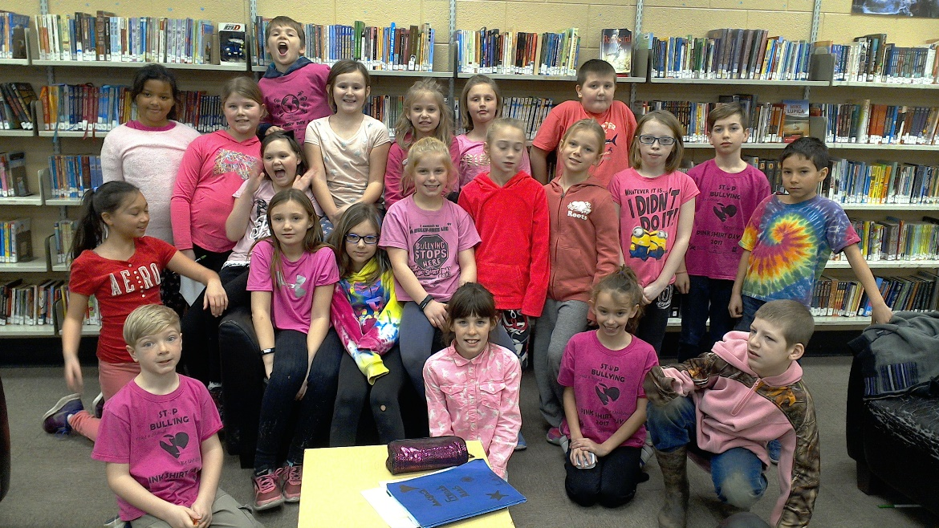 |  | March  - Newsletter for Room 116
Students supporting those who experience Bullying in schools |  | In This Issue

Let’s March on with our learning.
by [Article Author]
Reading: I have noticed that many students are struggling still with summarizing what they have read. We will work on this comprehension strategy for the month. Please encourage your child to read every evening. Ask them questions about what they have just read as well. Better yet, have them read outloud to you.
Writing: We have just finished reading biographies so each student is now writing their own autobiography, this should be very interesting!
Math: We are moving this month from multiplying and dividing to understanding how to use this skill to find the perimeter and area of 2D shapes.
Science: The students are designing and building structures that will house their pulley and gear systems. Ask your child about the benefits to humans of using a pulley or gear. Our next unit will be on rocks and minerals.
Social Studies: We will be learning about ancient civilizations in the spring.
Physical Education: We are right in the thick of Floor Hockey. We will continue this unit until after March Break. Then we will be learning about Badminton.
Arts: We will be learning a unit on dance after the March Break. In music, students will have an opportunity to sing Karaoke for our class, and if they are good enough, for the entire school. This should be fun!
The Classroom Remind App. I hope you are getting almost daily messages on your remind app. I try to let you know everything we are doing, or events coming up. Please use this app to communicate with me. Ask questions, or let me know important information.

