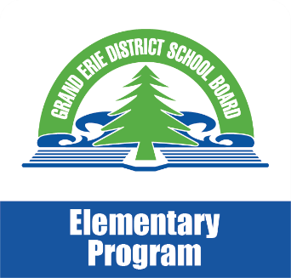
Math Moments
February 2018

How is Math Learning Assessed and Evaluated?
The goal of all assessments and evaluations is to improve your child’s learning. Both teachers and students contribute to the assessment process.
Assessment for and as Learning : The assessment process helps teachers make appropriate instructional decisions (assessment for learning), and helps your child to develop the ability to assess his/her own learning and set specific goals (assessment as learning). Before new learning begins, assessment can demonstrate to the teacher and the student what skills and knowledge already exist.
To help students monitor and direct their own learning, teachers identify learning goals and success criteria. Learning goals describe for students what they should know, understand, and be able to do by the end of a lesson, course, or unit. Success criteria describe what successful learning of the learning goals looks like. The teacher and students use these goals and success criteria to give feedback to each other.
As your child learns new knowledge and skills, both the teacher and your child collect information to demonstrate your child’s thinking and understanding. This is done through individual or small group conversations, by reflecting on how learning materials are used, and by analyzing work. This informs the teacher’s next steps and helps your child gather information about his/her own learning.
Your child will use the learning goals and success criteria to reflect on learning, celebrate successes, identify areas for improvement, make adjustments where needed, and set new personal learning goals.

Assessment of Learning: At or near the end of a period of learning, the teacher gathers information about your
child’s learning, to evaluate and summarize what has been learned and to make a decision on a grade. He/she talks
to and observes your child in the classroom, and looks at assignments, tests and projects, for evidence of what your
child knows and is able to do, and compares that against the expectations in the curriculum.

The Report Card: The report card summarizes your child’s achievement at two points in the school year. It gives a grade or mark for at least four of the five math strands each time. Each strand is reported on at least once in the school year. The report card also evaluates your child’s learning skills and work habits, essential for success.

EQAO: At the end of Grades 3, 6, and 9, your child will participate in a province-wide assessment of math learning
based on the Ontario curriculum for mathematics and what students are learning in classrooms every day. These
assessments are done by the Education Quality and Accountability Office (EQAO), an independent agency that
measures how well Ontario’s public education system is developing students’ math skills. EQAO test results are not
included on report cards in Grades 3 and 6 but provide important information to schools, districts and the province
about how we can continue to grow as an education system.

Taken from: Math Learning Today: produced in partnership with the Ministry of Education and Ontario District School Boards 2016

