DECEMBER!!!!

Focus This Month!
- Reading: Wrapping everything up! Reading the book Wonder!
- Writing: Focusing on paragraph’s and What Makes a Hero!
- Science: Continuing studying Habitats and Human Body Systems
- Math: Area and Perimeter

Reminders
- Book Orders Due Monday, December 11th
- Bring spare clothing for unforeseen weather
- Finishing our sit up challenge for DPA
- Christmas festivities happening!

Important Dates
- December 8th- Pizza Day
- December 11th- Compassion Assembly
- December 14th- Little Mermaid
- December 15th- Spaghetti Lunch
- December 20th- Christmas Concert and Soup Kitchen
- December 21st and 22nd – Christmas Party
- December 22nd- Last Day before break!!

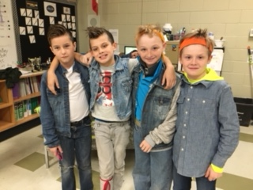
**** For the Christmas Concert….we are only doing the evening performance because we will be at the soup kitchen in the day time! Thanks for understanding!!****

