December 2017 | Compassion: Demonstrate kindness, care and thoughtfulness. Empathize with others.
Monday | Tuesday | Wednesday |  | Thursday | Friday | Saturday | Sunday
 |  |  |  |  | 1 Day 5 | 2 | 3
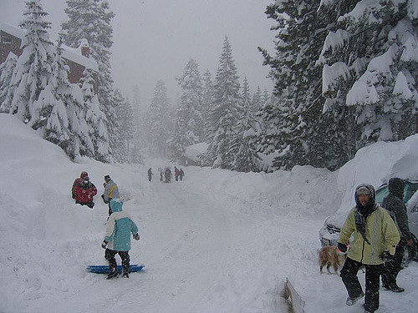 | December’s Pita Pit order is open on School Cash Online for ordering. |  |  |  | Pita Pit lunch
4 Day 1 | 5 Day 2 | 6 Day 3 |  | 7 Day 4 | 8 Day 5 | 9 | 10
Food & Baby Items Drive  Collection all week.  Thank you to our wonderful families for their donations. |  | Book Fair begins today, student preview only.  Open to families and friends from 3:05 – 4:00 |  | Book Fair – K-3 10:25-10:45  4-8 – 10:45-11:05  FF - 3:05 – 4:00 | Int. Girls VB Tournament at DSS  Book Fair – K-3 10:25-10:45  4-8-10:45-11:05; FF-3:05-4:00  Pizza lunch
11 Day 1 | 12 Day 2 | 13 Day 3 |  | 14 Day 4 | 15 Day 5 | 16 | 17
Last day of Book Fair for students.  K-3-10:25-10:45; 4-8-10:45-11:05 |  |  |  |  | Jr. Co-ed VB tournament  Julia’s Bistro Chicken Nuggets & Caesar Salad lunch |  | 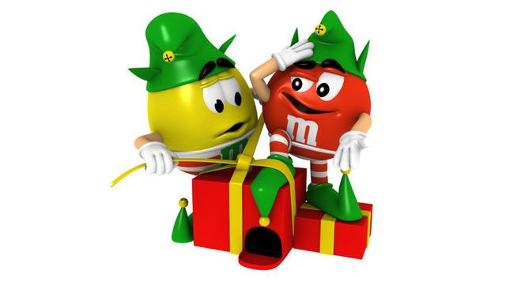
18 Day 1 | 19 Day 2 | 20 Day 3 |  | 21 Day 4 | 22 Day 5 | 23 | 24
Holiday PJ Day  Candy Canes being sold daily this week for 50¢ ea. 4 max/person/day  Ed. Tech Crew to Brantford  Christmas Carols @ 9 led by Gr. 8  All are welcome to join us | Holiday Hat Day  Primary Christmas Concert  Dress Rehearsal 11:30 a.m.  Evening Performance 6:30 p.m.  Christmas Carols @ 9 led by Gr. 5. All are welcome to join us | Holiday Sweater Day  Christmas Carols @ 9 led by Gr. 6. All are welcome to join us |  | Holiday Character Day  Annual Turkey Lunch  **Don’t forget your plate and utensils**  Christmas Carols @ 9 led by Gr. 4. All are welcome to join us | Wear it All Day  Pizza lunch  Christmas Carols @ 9 led by Gr. 7  All are welcome to join us
25 | 26 | 27 |  | 28 | 29 | 30 | 31
The staff at Fairview Avenue School wish our Falcon Families a safe and happy holiday season!

Upcoming Dates:
Monday, January 8 – First day of school in 2018.
Monday, January 22 – P. A. Day, no school for students

