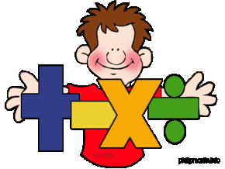
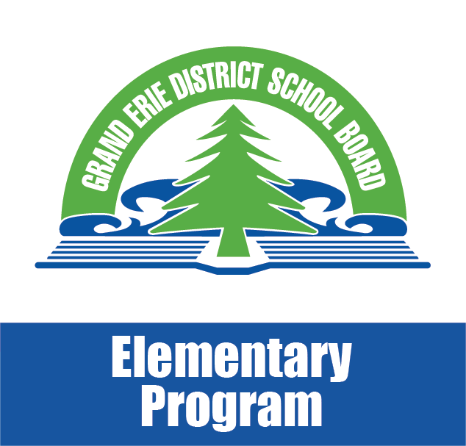
Math Moments
December 2017

Talking Math with Kids is Important

Do you talk math with your kids?
Most people feel comfortable talking about words, sentences and letters with their children. We read to them at night and help them figure out how to decode words in stories. It’s natural for most of us to notice messages on billboards and street signs and restaurants. When it comes to math, we don’t seem to be as comfortable. Talking to kids about numbers, fractions and decimals doesn’t seem to come as naturally.
Did you know that:
- Research shows that “speaking math” at home with young children has a strong correlation with their achievement in math once they get to school?
- Parents “talk more math” with their sons than their daughters?
- Familiarizing young children with number words helps to create an interest in math in later years?
- The more you “talk numbers” with your young children, the greater understanding they will have of basic math concepts
- “Speaking math” at home benefits students of all grade levels; demonstrating the real life connections as well as deepening understanding
How can you bring numbers into conversations with your children?:
- Notice and talk about numbers on signs (speed limits, distances, addresses, 911 numbers)
- Engage young children in counting (toys they are playing with, pieces of food on their plate)
- Refer to the calendar, number of days until an event, weeks, months?
- Discuss weather predictions, temperatures
- Discuss sport statistics, numbers in video games, baking measurements, costs of items - tax
- Encourage older students to read decimals using quantity; ie. 1.2 is (one and two tenths), 0.004 (four one hundredths)

Taken from: “Why It’s Important to Talk Math With Kids” Annie Murphy Paul

