November 2017 | RESPECT: Treat yourself, others and the  Environment with dignity.
Monday | Tuesday | Wednesday | Thursday | Friday | Saturday | Sunday
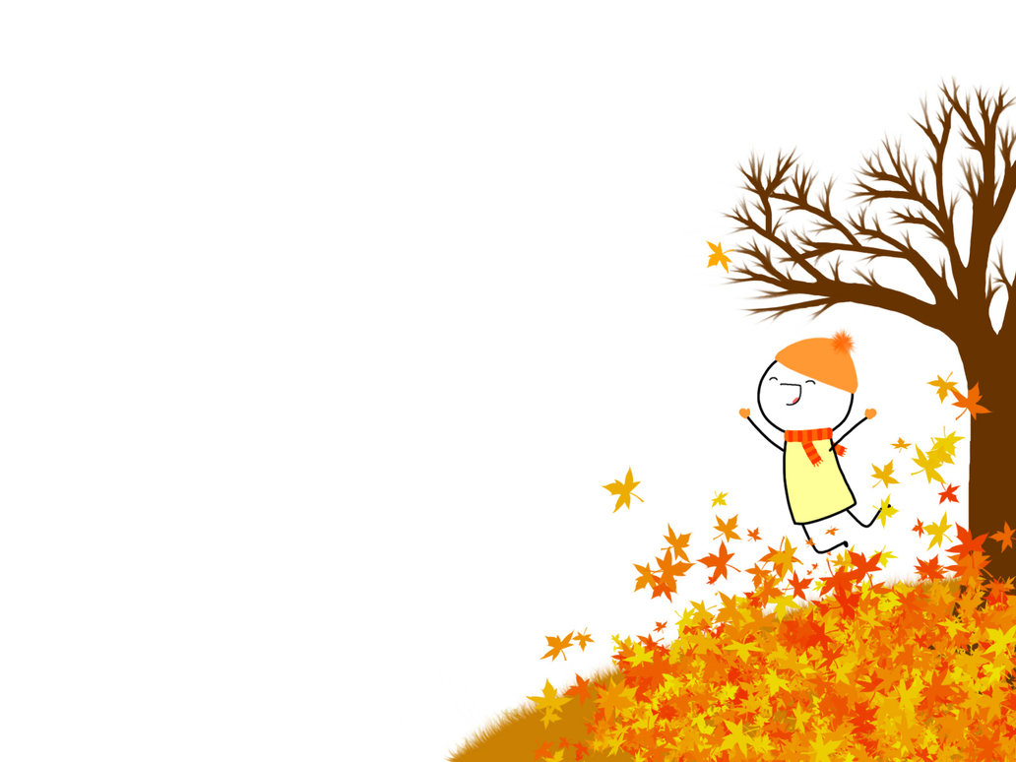 |  | 1 Day 4 | 2 Day 5 | 3 Day 1 | 4 | 5
 |  | Take Your Kid To Work Day! |  | Bus Evacuation training for students – 9:00 a.m.  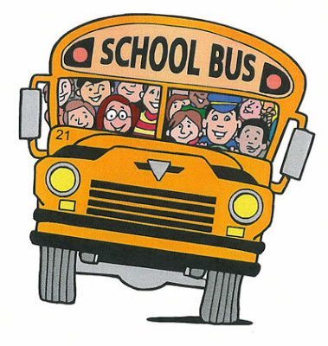 Pita Pit Lunch |  | Turn clocks back 1 hour.
6 Day 2 | 7 Day 3 | 8 Day 4 | 9 Day 5 | 10 Day 1 | 11 | 12
Treaties Recognition Week |  |  |  | Remembrance Day Assembly 9:00  Pizza Lunch | 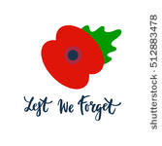 | Fairview Ave. School will be represented at the Cenotaph.
13 Day 2 | 14 Day 3 | 15 Day 4 | 16 Day 5 | 17 | 18 | 19
Provincial Progress  Reports go home today.  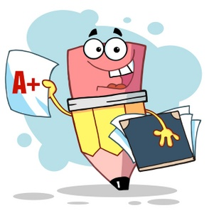 | Photo Retake Day |  | K-8 Interviews  3:30-5:00  6:00-8:00 | K-8 Interviews 9:00-12:00  P.D. Day  No School for Students
20 Day 1 | 21 Day 2 | 22 Day 3 | 23 Day 4 | 24 Day 5 | 25 | 26
Grade 8’s going to DSS |  | 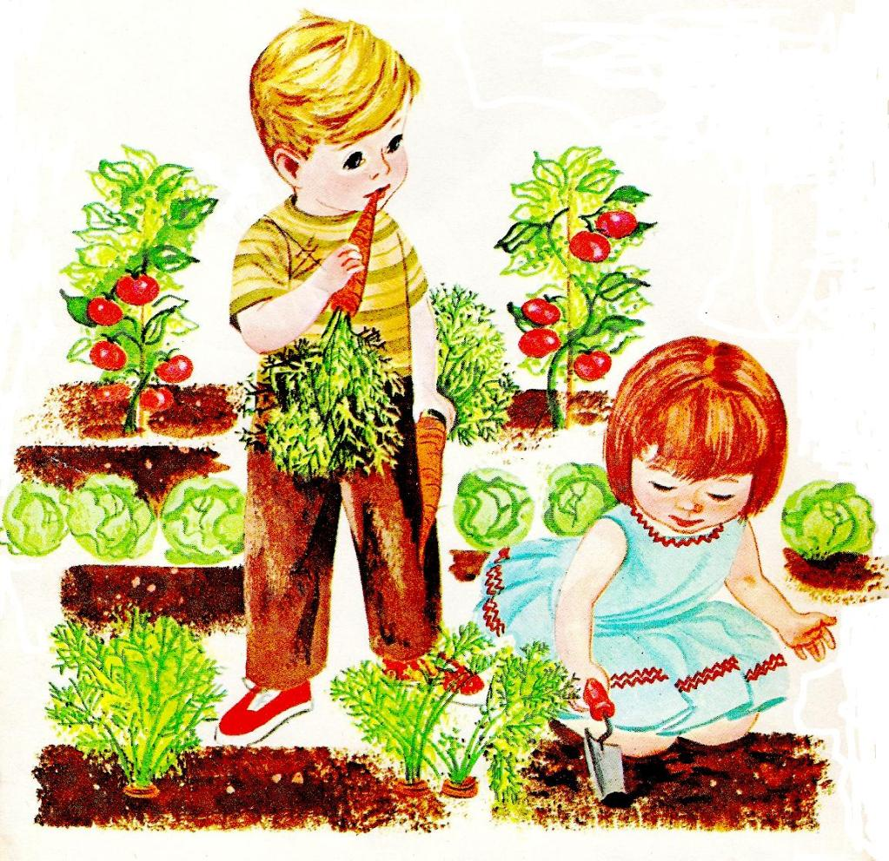 |  | Accessibility  Awareness Day! 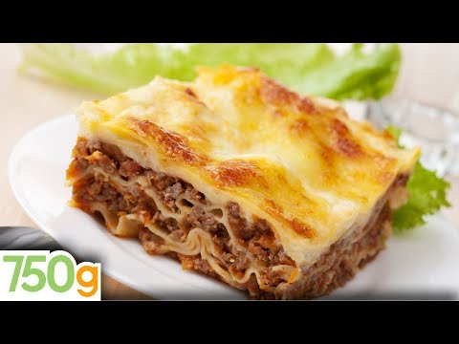 Lasagna Lunch  Lasagna Lunch
27 Day 1 | 28 Day 2 | 29 Day 3 | 30 Day 4 | Upcoming Dates:  Book Fair – 1st week of Dec.  Turkey Dinner – Dec. 21  Christmas Concert – Dec. 19  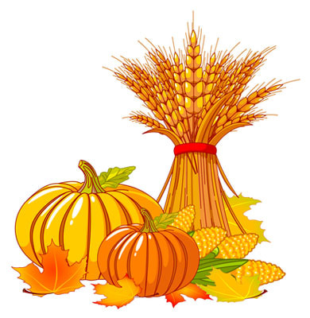
Int. Boys Volleyball Tourney @ CSS
