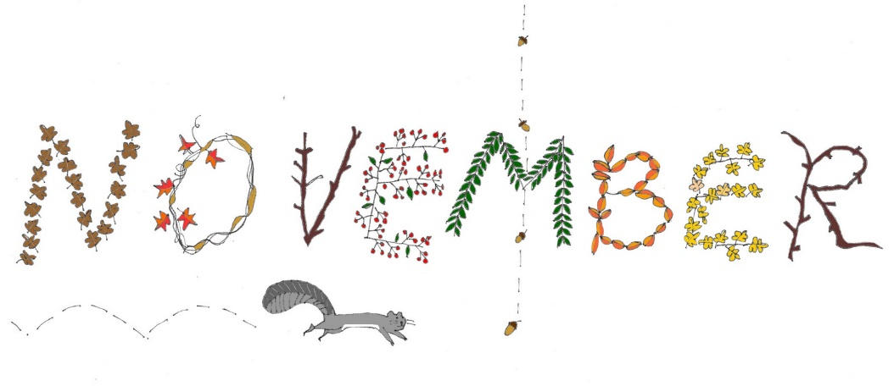
Mrs. Packham Grade 1
Dear Parents,
Welcome to November, I hope this month will be filled with activities to help your son/daughter work independently and in small groups successfully. We are working on building our stamina when it comes to reading independently and reading with a partner. I am happy to announce that the website is up and running and you can find the newsletter and calendar there as well as on the Class Dojo. This months Character Attribute is Cooperation.
General Information
Newsletters…. Each month I will be posting a newsletter and caldendar to the Thompson Creek Elementary School’s website and on the Class Dojo, highlighting events from the past month and what is coming up in the current month.
Communication Books…These are getting hard to follow and find notes that are sent in. I am going to ask from now on if you are sending a note and you do not want to send it through Class Dojo please date your note and write it in the back of the book. I will also write any notes to you in the back of the book and date them. I will also use the Class Dojo to communicate messages to you.
Show and Tell… A way for your child to share with his/her classmates what they love and know will be through show and tell. Sharing for the month of November is “My Favourite Book”. Please have your child bring in their favourite book to share with the class. If they are able to read the book then they can read it to the class, if they are not able to read it I will read it to the class. Practice at home with them so they are ready to tell the class why it is their favourite book and what their favourite part of the book is.
Class Dojo….I am happy to report that we have 95% of our class connected through the Class Dojo. I will continue to send out messages about upcoming events and I will continue to post pictures of things happening in our classroom. If you would like to see something posted that isn’t being posted please let me know. I have started using the individual student stories this past week. When I take pictures of your childs work I will post it in their student story so I have a record of it and you can also see the work that they are doing. If there is a comment under the picture it is what they told me about the work they completed.
Physical Education/DPA…. We will have either Physical Education or DPA (Daily Physical Activity) everyday. Please make sure that your son/daughter has running shoes to participate. A change of clothes is not necessary. They will have Mr. Taylor for Physical Education.
Library…. We are scheduled to go to the library on Day 1 with Mr. Overend and Day 3 with myself. Please return books as you are done with them and we will get them switched for a new one as soon as we can.

Focus:
Reading – We will continue with the short vowel sounds this month. We are also learning reading strategies to help us when we get to tricky words. Ex. Stretchy Snake – Stretch the word out and say each sound then put the sounds together quickly.
Writing – We are going to work on using capitals, periods and finger spaces in our writing. We are going to start adding details to make our sentences more interesting.
Math – We are going to finish up our unit on Patterning and start Data Management (graphing).
Science – We will be finishing up with the Needs and Characteristics of Living Things
Social Studies – Relationships, Rules and Responsibilities.
Notes from the Office
Due to allergies we will not be handing out any snacks/treats to the entire class so please do not send anything from home to share.
We are attempting to decrease our consumption of paper therefore newsletters and calendars will be posted online.
Please register for online payments, this is where you will be able to pay for anything school related.
Please feel free to contact me at the school or through the Class Dojo with any questions that you have.
Let’s have a great year!
Mrs. A. Packham
905-774-5460

