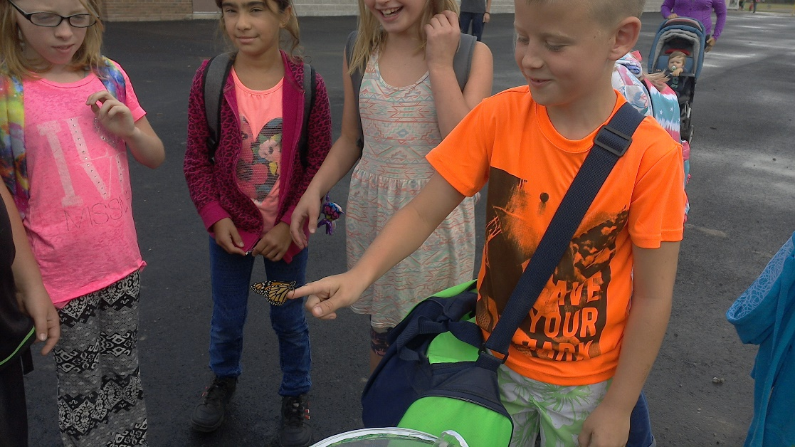 |  | Grade 4  - News  - October 2017

Releasing our Monarch Butterfly
Check out what’s up in Grade 4
Literacy:
We have just learned about the many strategies that help us become better readers. Comprehension, Accuracy, Fluency and Expanding our Vocabulary are the four areas we will focus on all year. This month we will be practicing the skill of summarizing and getting the main idea. In writing we are continuing to practice writing great sentences into an interesting spooky story.
Math:
Our new unit this month is all about measuring. Students will learn to estimate and accurately measure in mm, cm and m. If you can make sure your child can count quickly forward and backwards, this will help greatly.
Social Studies: A new unit on Canada will be starting at the beginning of November.
Science:
We are continuing to learn about habitats. Talk about the plants and animals near your house and how they survive using their habitats.
Arts: We will be learning about the elements of design, specifically line, shape and texture in visual arts. We are also going to learn some songs to present at assemblies coming up for music.
Physical Education:
Now that we have finished our units on soccer, orienteering and cross country we are learning how to play football, then we will move into the gym to learn some good ‘ol dodgeball games.
Notices: Throughout the year we will be having several class parties. I will plan the activities for the first few parties, and students will help organize the last few. We are not having students bring in food for these parties, the plan is to make our own food here at the school to enjoy at the party. The parties this year will be as follows:
Halloween: On Tuesday Oct 31, it is Halloween day. Like every year we will have a costume parade in the gym at about noon. You can send your child’s costume with them and I will give them time at 11:30 to change. Class party to follow in our room.
Christmas: The last day before Christmas Break we will have games and activities in our room.
Valentines: On Valentine’s day I will give students time to hand out the valentines they made, then we will have some fun and games in the classroom.
Spring: On the Thursday before the Easter break, we will be having some spring games in the room as well as make some yummy treats.
Summer: On the last day of school the students will be required to design and plan their own game with a group. We will have fun outside playing these water games and enjoying a few cool treats.
Communication: Don’t forget to check your child’s agenda each day. Sometimes your child will get homework or a note from me. Also, check in on our class blog to see pictures of what is going on in our room. You might even see your child’s happy face!!

