Elgin Avenue Public School January 2018
ELGIN IN THE NEWS

Character Trait  We are continuing with the character trait Compassion through the month of January. Compassion is where you care about others or towards something. You can show compassion by helping others when they need it or doing nice things for other people. So keep up being compassionate through the month of January. | 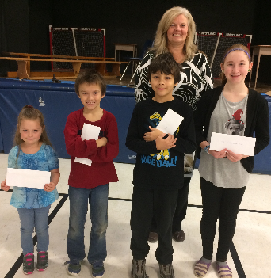  Be Well  We had our Be Well draw during our December Character Ed Assembly. Many students participated by filling out their Be Well cards, which then entered them into the draw. Prizes included gift certificates to Child’s Play Indoor Play Area, the White Horse Bowling Alley, and The Strand Theatre. We even picked a winner among staff!
Inclusiveness  November’s character trait was inclusiveness. Students who demonstrated inclusive behaviour were nominated by the teachers to receive a certificate during our assembly.  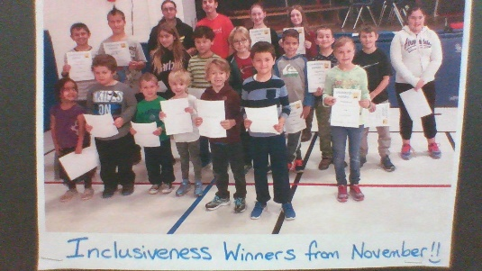 | Grade 8 Information Session  Simcoe Composite School is hosting a Grade 8 Information Session on Tuesday January 16, 2018 from 6:00 p.m. to 7:30 p.m. Welcome and an information session will begin at 6:00 p.m. in the gym. Students and their parents/guardians will be able to tour the school and talk with our staff. Looking forward to seeing all our future Sabres.

Caring Cupboard Food Drive  The students at Elgin participated in collecting non-perishable items for the Caring Cupboard during the month of December. Each classroom collected points based on the number of items that were donated. The classroom that collected the most points was Mrs. Sullivan’s class. Great job everyone! We would also like to thank all the families that brought in food items to our Winter Variety Show. Your generosity was appreciated. | Important Dates  January 22- P.A. Day  Spirit Days  January 12 – Neon Day  January 19 – Canadian Sport’s Day  January 26 – Superhero Day
Elgie’s Holiday Feast
Students had a blast at this year’s 3rd annual Turkey Dinner. We are extremely grateful to the parents and volunteers who made this event possible again this year.
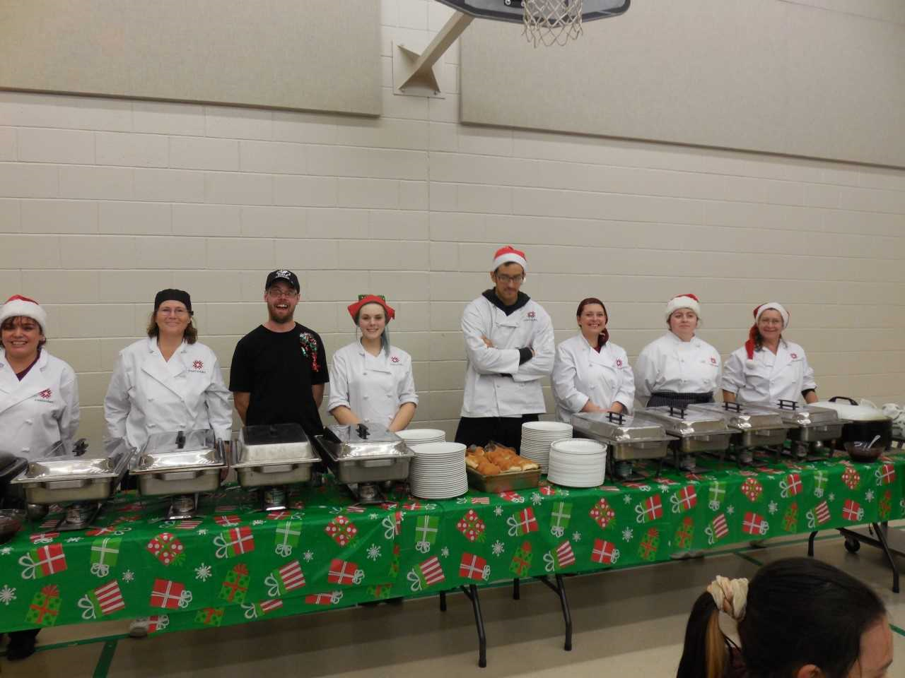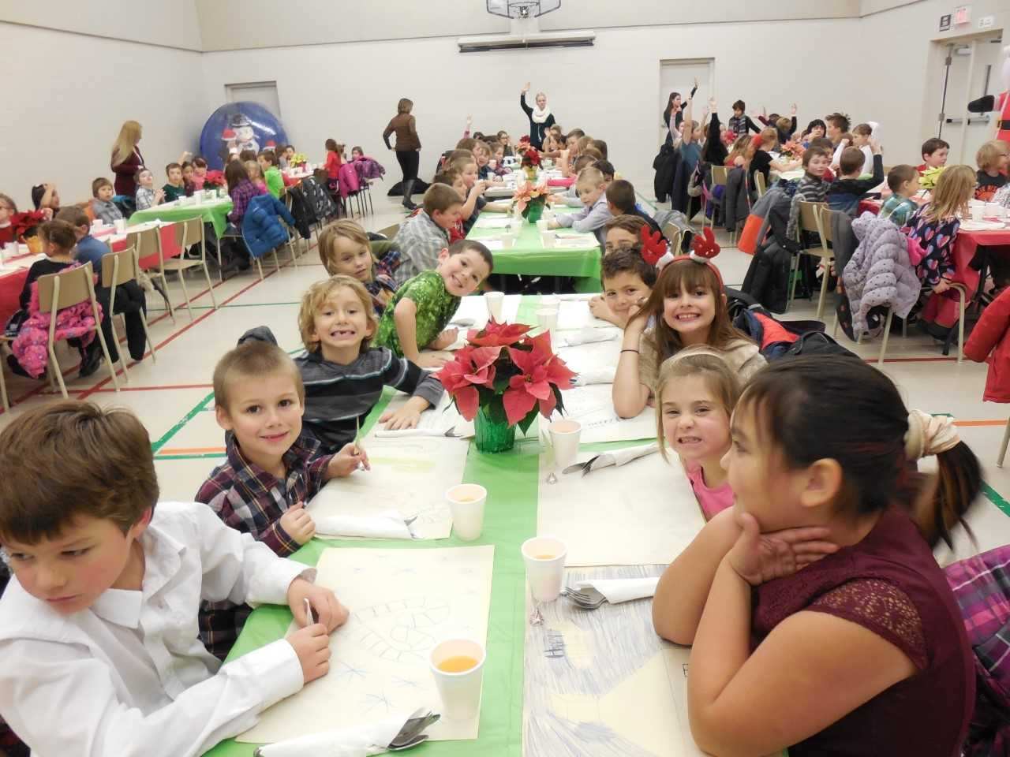
Two lucky students also won some special prizes during our holiday feast, thanks to the parent group.
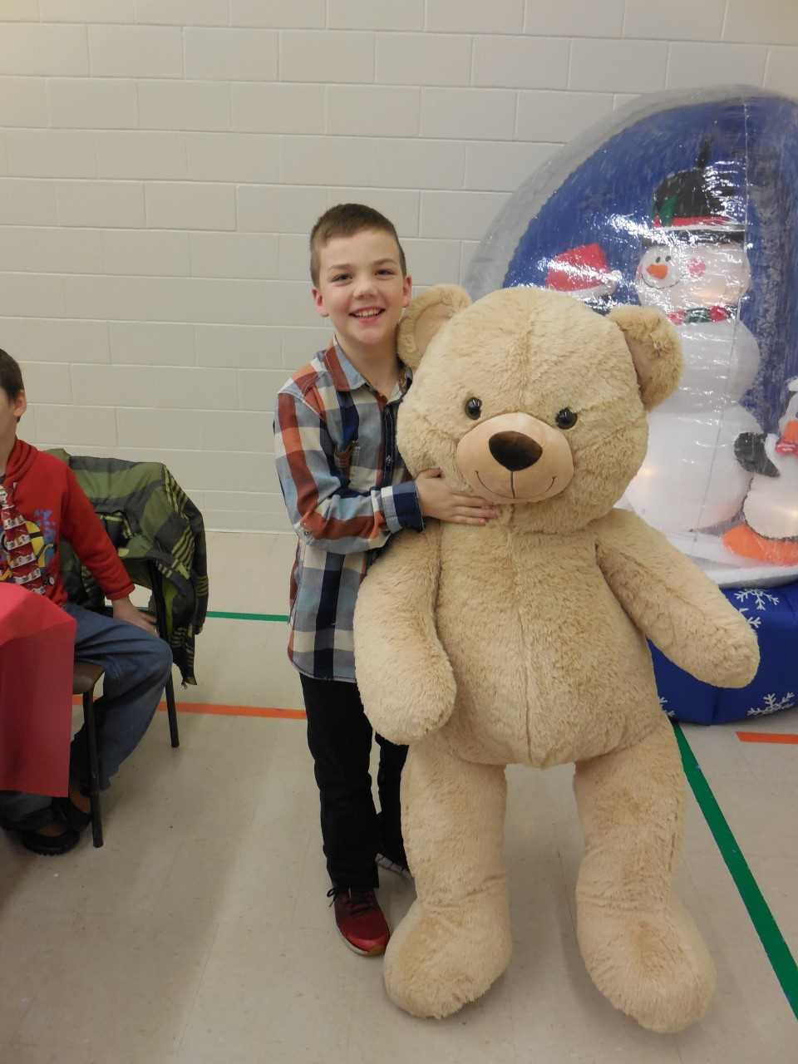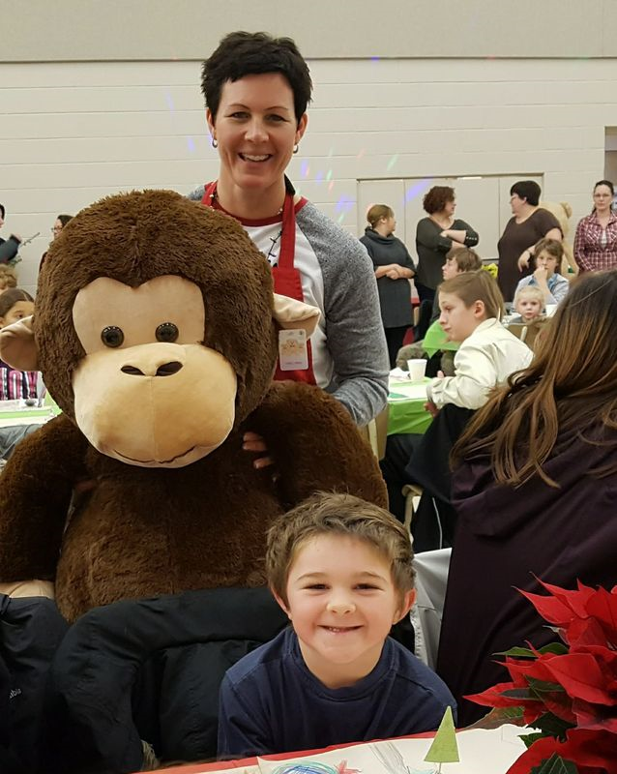

Winter Variety Show
For the second year in a row Elgin hosted a Winter Variety Show. Each classroom presented a song, or a dance for their friends and family. They all worked very hard in their rooms, and we hope you enjoyed the show.
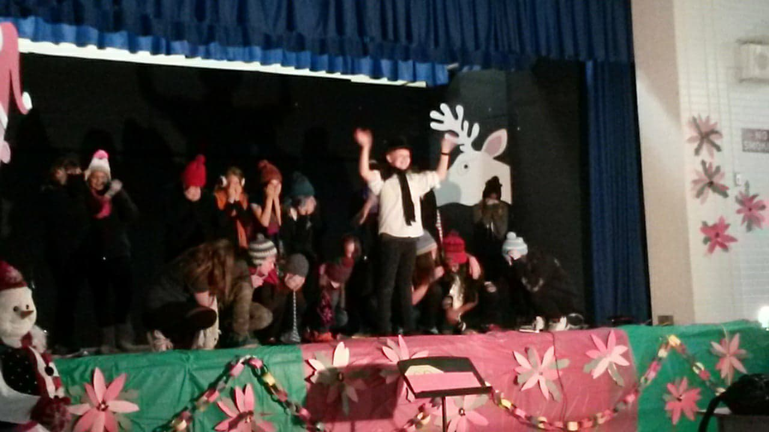
Kindergarten Registration  Kindergarten registration begins this month. Children eligible for Kindergarten must be four years old by December 31st 2018. Please contact our school to register. We look forward to meeting our future Eagles. | Volleyball  Congratulations Eagles!! Each division did an amazing job representing our school in each tournament.

