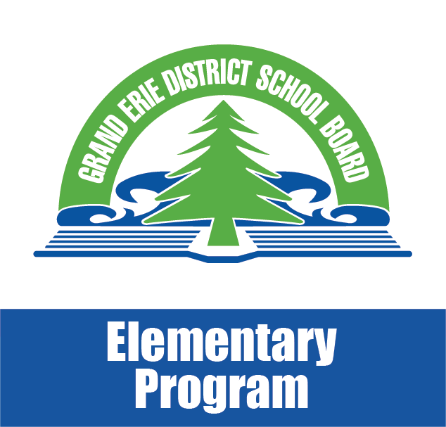
Math Moments
November 2017

Math in Everyday Life

Sample Activities that Involve Math
Kindergarten to Grade 3
I’m decorating this cake with blueberries and strawberries in a pattern. What berry should I put next?
We have leftover food. Which size of container should we use to store it for later? Why?
How many different types of vegetables are in the cart?
We have 14 candies and 6 of them are red. How many of the candies are not red?
Let’s sort the laundry into white clothes and coloured clothes. Let’s count the blue socks by 2s. How many are there?
Twelve guests are coming to the party. There are 4 of us. Do we have enough plates and utensils for everyone at the party?
Grades 4 to 6
We need to pay the cashier $4.85. What combinations of coins could we use to give the cashier the exact amount?
It costs $6 to buy 2 cartons of eggs. How much would it cost to buy 3 cartons of eggs?
This bag of soil is 20 L. How many 1.5 L pots can we fill to grow our tomato plants?
It takes us 25 minutes to get home from school. What time do we need to leave home to get to school by 8:50 a.m.?
How much do you think the groceries in our cart will cost? What are some strategies we can use to help us figure this out?
A new friend is being invited over. Write directions so that your friend will know how to get to our home.
Grades 7 & 8
One store is selling the game you want for 30% off $26. Another store is selling the same game for 10% off $19.99. Which store has the better deal?
This muffin recipe uses 1-1/4 cups of flour. How many cups will we need for 2-1/2 batches?
We can either buy a 5-kg bag of potatoes for $3.50 or a 3-kg bag of potatoes for $2.40. Which is the better value? According to the weather channel, it will be 8ºC today. The temperature will drop 10ºC overnight. What will the temperature be tomorrow?
About how much is a 15% tip on the cost of this meal?
Predict changes in the batting average of a favourite World Series baseball player, based on his/her performances in recent games.

Taken from: Math Learning Today: produced in partnership with the Ministry of Education and Ontario District School Boards 2016

