# 

**November 2017**

**Newsletter**

Principal: Mrs. C. Stewart Secretary: Mrs. H. Epp Contact us at (519) 688-2110  
Website: http://www.granderie.ca/schools/courtland



We are well into our first term and Courtland Public School is up and running at full speed! We have many events and activities at our school, in addition to our fine academics, which provide many opportunities for our students. Our annual Remembrance Day Assembly will be held November 10, 2017 at 11:30 in the gym. All are welcome. Thank you to Mrs. Scruton and Mrs. Willson for their efforts in organizing what promises to be a very moving and meaningful morning for our students. Our 2017-2018 Student Government has been elected and have begun their work for the year. We have an excellent group of leaders on this council and are therefore going to take advantage of their skills. Thank you again to Mrs. Box for her leadership with this group. We are very thankful to all of those who work so hard to provide all of the extra activities that make our school such a great place to learn. Progress reports will be going home on November 13, 2017 for students in Kindergarten to Grade 8 and Parent/Teacher Conferences will be held on Thursday November 16, 2017 from 4-7 p.m. and on Friday November 17, 2017 from 8:30-11:30, in the meantime, if you have any concerns or questions about your child’s progress, please contact their classroom teacher who is always available to discuss your child’s progress with you.

**Important Upcoming Dates:**

|  |  |
| --- | --- |
| November 1 | Take Your Kids to Work Day |
| November 2 | Key Bible Club |
| November 8 | MADD Presentation – grade 7 & 8 |
| November 9 | Key Bible Club |
| November 10 | Red, White & Black Day / Remembrance Day Assembly |
| November 13 | Progress Reports go home |
| November 14 | COPE meeting 6:30 in the library |
| November 15 | Wendy’s Hot Lunch |
| November 16 | Key Bible Club / Parent / Teacher Conferences 4-7 p.m. / Shoe boxes due Colour House Day |
| November 17 | P.D. Day / Parent / Teacher Conferences 8:30-11:30 a.m. |
| November 22 | Grade 8 Orientation Day @ VHSS |
| November 23 | Key Bible Club |
| November 24 | Month End Assembly 2:15/ Accessibility Awareness Day |
| November 29 | Grade 8 Orientation Day @ DDSS |
| November 30 | Key Bible Club |
| December 5 | Family Holiday Celebration Night & Book Fair |

PrincipalPO Box 245  
1012 Queen Street  
Courtland, Ontario  
N0J 1E0  
519-688-2110

**Principal**

**Mrs. D.** Opersko

**Office Coordinator**

Mrs. J. Hedge

**Tigers Den**

Congratulations Tigers! Our Intermediate Soccer Team Won a pennant for the “A” Division at our county tournament and then went on to the CAGE tournament to represent Norfolk County at the Grand Erie wide tournament. Our Junior Soccer team also had a fine showing at the tournament – as they made it to the “A” Division playoffs – thanks Miss Varga!

Our Cross Country team

also had a very fine

showing at the county

meet. Our senior relay

team placed first

– another pennant and

Several of our individual

runners placed at the

top of their category and they will be going to the CAGE run in the near future. We also have some very fine primary cross country runners! Congratulations on doing well at our “Mini-Meet” and thanks Mrs. Swayze!

Up next …. Volleyball. Go Tigers!

**Pick Up Routine:**

Students waiting to be picked up by a parent or guardian at the end of the day will exit through the front doors of the school. I**f this is the student’s regular dismissal routine**, it is not necessary for parents to come to the office to sign their child(ren) out.  **If, at dismissal time, someone other than the regular person is picking up a child a note must be sent to the teacher and they also must come to the office, show identification and sign the child out**. If you, are picking your child up early from school, you must come to the office to sign them out. If someone else is picking your child up early, you must send a note in the agenda and that person must come to the office and sign the child out. These practices will ensure the safety of our students.

# cid:0BC652A6-1647-4689-BFC4-61B26DF0EAB7Image result for united way canada

**Character Education   
- Compassion**

Our Character Education focus for the month of November will be “Compassion”. Our students are learning about what is means to be compassionate towards others; an important attribute to be successful in school and in life. Please help us and reinforce our teaching at home.

and do not require a pass to enter the fairgrounds

**Breakfast Program Fundraiser**  
Our MacMillan fundraiser was a huge success. We raised $2111.00 which goes directly to the **Breakfast Program**. Keep an eye out for our upcoming Cinnabon Fundraiser coming out in November. Fresh cinnamon rolls for Christmas! Thanks very much for supporting our daily **Breakfast Program** and thank you Mrs. Fehr for organizing these fundraisers!

**Remembrance Day Assembly**We will be having our annual   
Remembrance Day Assembly   
in the gym on Friday,   
November 10, 2017 at 11:30.  
Guides, Brownies, Cubs, Scouts,  
Beavers and Cadets are invited to wear their uniforms to the assembly. It is suggested that these students bring a change of clothes for the rest of the school day. Poppies will be provided on Friday, November 10th, prior to the assembly. Donations for poppies would be appreciated. Parents are most welcome at the assembly.

**Hat Day for the United Way!**Well done Courtland students! We raised $70 for the United Way on Hat Day.

**Kindergarten Reports** Starting this year, the Kindergarten reporting schedule will be aligned with the  
 grade 1-8 reporting schedule. Kindergarten progress reports will be going home on   
November 13, 2107 and parents may schedule an interview on Thursday, November 16  
in the evening or on Friday, November 17 in the morning. We will no longer be doing conference reports where parents visit the classroom to observe and speak to the teacher during this time.   
Information about scheduling an interview will be coming home soon.

**COPE COUNCIL**  
Look for the upcoming COPE Poinsettia Fundraiser campaign this coming month. COPE is also, once again, planning our annual Holiday Dinner for December 22. Also in the works for this school year, a dance-a-thon and the calendar fundraiser in the spring. Thank you to the dedicated members of this group who do so much to enhance your children’s experiences at Courtland Public School. The next meeting is scheduled for Tuesday, November 14, 2017 at 6:30 in the library. All parents are welcome!



**Wendy’s Wednesday**  
COPE has organized a hot lunch day from Wendy’s on November 15. An order form will be coming home soon. Thanks COPE!

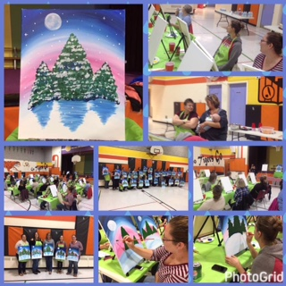

**SCHOOL WEB SITE**Please visit our new and improved school website, featuring a monthly calendar!

Website: http://www.granderie.ca/schools/courtland

**PAINT NITE FUNDRAISER**  
The Paint Nite fundraiser was again a success and a fun night out! Thanks very much Mrs. R. Lockstein for organizing the event!

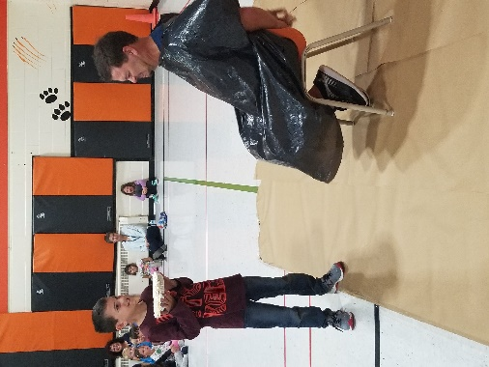

**Teachers Take One for Terry!**

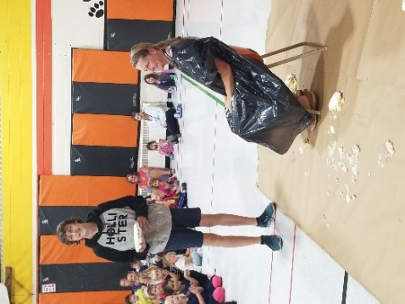



**Operation Christmas Child**  
Once again, we are running the “Operation Christmas Child campaign. Fill a shoe box full of gifts for a needy child and make their Christmas special!

Your interest in Courtland Public School and your continued support is appreciated. Please call Mrs. Stewart if you have any follow up questions or concerns regarding this newsletter.

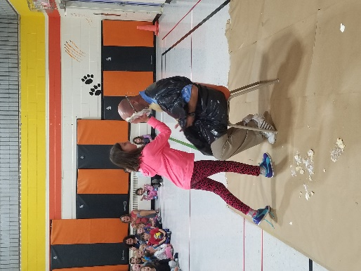

**Colour House Day**  
Show your school spirit and wear your house colours on Colour House Day, November 16 – 50cents.

# 