# 

**October 2017**

**Newsletter**



Principal: Mrs. C. Stewart Secretary: Mrs. H. Epp Contact us at (519) 688-2110  
Website: http://www.granderie.ca/schools/courtland



We are off to a very fine start to the 2017-2018 school year. Everyone is settling nicely into school routines and our classroom programs are up and running. Our board-mandated, uninterrupted literacy blocks are scheduled for during the first instructional block. Please ensure that your children arrive on time so that they are not interrupting literacy lessons which have already started. Focused and uninterrupted literacy instruction is a proven, effective approach to improving children’s literacy skills. Our board also has moved to an uninterrupted numeracy block of 60 minutes per day. This increased focus on mathematics instruction will support our efforts as we continue to work on math instruction that enables children to learn through an active, problem-solving approach. We will also focus on character education. Our plans include a **monthly assembly, at which parents are always welcome**, principal awards and a recognition bulletin board in the front hallway. Our character education focus for October is “**respect”.** Please help by encouraging and reinforcing the concept of respect at home.

I would like to take this opportunity to wish all of our Courtland families, a very Happy Thanksgiving!

**Important Upcoming Dates:**

|  |  |
| --- | --- |
| October 2 | Junior Soccer Tournament in Delhi |
| October 3 | P.D. Day / Youth Canada Day @ the Norfolk County Fair / Road Race |
| October 4 | Grade 3 / 4 & 4 / 5 Fair Trip / Junior Soccer rain date |
| October 5 | World Teacher’s Day / Intermediate Soccer Tournament / Key Bible Club begins |
| October 6 | Intermediate Soccer rain date |
| October 11 | Grade 2 and 3 Backus Trip / MacMillian’s fundraiser due |
| October 12 | Cross Country Meet in Simcoe / Dairy Farmer |
| October 16 | Cross Country rain date / IEPs go home |
| October 17 | Immunizations |
| October 19 | The Great Big Crunch / Dairy Farmer Presentations |
| October 22 | Primary Cross Country Mini-meet 2:00 p.m. |
| October 24 | Mini-meet rain date / C.O.P.E. Meeting 6:30 in the library |
| October 25 | MacMillan’s delivery /Paint Nite fundraiser |
| October 27 | Assembly 2:15 – all parents are welcome |
| October 31 | Hallowe’en |

PrincipalPO Box 245  
1012 Queen Street  
Courtland, Ontario  
N0J 1E0  
519-688-2110

**Principal**

**Mrs. D.** Opersko

**Office Coordinator**

Mrs. J. Hedge

# 

**Baked Goods**

We are happy to accept snacks and treats for special occasions (birthdays, Hallowe’en etc.). However, the Ontario Public Health Association no longer supports home baked or prepared food for students; therefore, food sent to school has to be purchased from a recognized facility that has been approved by public health inspectors.

This means that we can no longer have bake sales at school, nor can we give students cupcakes, cookies etc. that have been made in private kitchens. We can only accept pre-packaged, purchased treats from grocery stores on special days. **Please remember that we are a nut free school.**

**MacMillan Fundraiser**  
Orders for the breakfast program fundraiser are due on October 11 and items will be available for pickup on October 25 from 2-5 p.m. Thanks very much for supporting our daily **Breakfast Program** and thank you Mrs. Fehr for organizing this fundraiser!

**Tigers Den**

The primary cross country runners (grades 1&2) are off to a great start this year! Our school’s “mini meet” will take place on Friday, October 20 at 2p.m. The rain date will be

Tuesday, October 24 (same time). Parents are welcome to come and cheer on the participants. Our junior/intermediate cross country team will be off to their meet on October 12. Thanks Mrs. Jansen and Mrs. Devlin assisting with the team. Soccer tournaments kick off with the junior on October 2 and the intermediate on October 5. Thanks to Miss Varga and Mr. Smith for coaching these teams! Go Tigers, Go!!

**The Great Big Crunch**On Thursday October 19 we will be   
joining students across Canada in   
The Great Big Crunch to promote the healthy benefits of eating **locally grown** apples!

# Image result for young canada day norfolk county fairImage result for great big crunch

**Terry Fox Event**On Thursday, September 28, 2017 we held our annual Terry Fox run to raise money for cancer research. Our students raised **** . Thanks Mr. A. for organizing this event.

**Young Canada Day at the Norfolk County Fair**  
Tuesday, October 3 - Young Canada Day at the Norfolk County Fair – has been designated as a Professional Activity day by the Grand Erie District School Board.   
Except for scheduled events (like the Road Race), there will be no supervision of elementary students on this day.  Students will be admitted free to the Fair on Young Canada Day   
and do not require a pass to enter the fairgrounds

**Parents/Guardians/ Community Members on the School Yard:**

Although parents, guardians and community members are always welcome at the school, the safety of the children is of utmost importance. We ask that parents, guardians and community members do not come onto the yard without first signing in at the office to make your presence known. Parents are asked to wait outside the fence before or after dropping students off at the beginning or ending of the day. Pets are not permitted on the yard. The area directly in front of the school is a no parking zone. This space must be kept free of vehicles at all times. This is the place emergency vehicles will park in the event of a fire.



**Our School’s Belief Statement**: At Courtland Public School we believe that our students come first in all of our

decision making.

**Our Daily Challenge** for all members of our school community is to create and maintain a learning and working

environment which:

•is inclusive, welcoming and safe

•fosters respectful and responsible relationships

•has high standards for achievement

•is engaging and encourages each member to reach his or her potential

•recognizes the interests and qualities which make each member unique and valued

•encourages leadership, problem solving, critical thinking, and effective communication

•includes the use of computer technology throughout the learning day

•inspires an open mindset and a passion for learning

**Congratulations to our 2017-2018 Student Government Executive!**

Prime Minister: Addi Bartik

Deputy Prime Minister: Avri Sowa

Minister of Social Events: Jack Soares

Minister of Communications: Ayslinn Clark

Minister of Scheduling and Recording: Sarah Friesen

Minister of Finance: Samson McDonald

Thanks Mrs. Box for organizing this opportunity for our students!

**Hat Day for the United Way!**Please help us raise funds for the United Way – an organization that supports so much in our community! Bring a **loonie** on October 13 and wear your hat at school!

**Paint Nite Fundraiser**Please join us for a fun and creative evening and help us raise funds for the   
school at the same time! COPE is hosting a Paint Nite on October 25 in the gym  
at Courtland P.S. The cost is $45 which includes some light refreshments.   
You will be able to create and keep this beautiful piece of art in purples and blues   
and have a lot of fun at the same time.

Please register at https://www.paintnite.com/events/

# cid:image001.jpg@01D332C8.9108FE10

**2017-2018 C.O.P.E EXECUTIVE**Chair: Rhonda Vandervene   
Vice Chair: Daniel Jones  
Secretary: Robin Lockstein & Laura Townsend  
Treasurer: Mandy Belore

**MEMBERS**Sally-Jo Atkinson-Jones, Arlene Robinson, Cynthia Tosswill, Shelagh Csanyi, Tara Lesage, Sarah Fehr, Lindsay McKie, Crystal Paton,

**Spirit Events**  
Our student government is planning a few activities. There will be a dance on October 27th and October 31 is orange and black day. The group will also be planning some fun Hallowe’en activities. Show your school spirit and wear our Hallowe’eny school colours!

**Playground Grand Opening**

Thanks to the efforts of our awesome COPE group our students and the community are the lucky recipients of a fabulous new playground structure. The Playground Committee, Sally-Jo Atkinson, Robin Lockstein and Rhonda Vandervene, took on the task to raise funds to pay for our new equipment. They raised an unbelievable $50,000 in one short school year and over this summer the new equipment was installed. Many thanks to our sponsors:

Jamie & Rob Bilger COPE  
Courtland Firefighters Courtland Lions  
Dana Cadman – Norfolk Cattle  
Melissa McDonald Prouse Mechanical  
Townsend Lumber Trackless Vehicles

This would never have been possible without your support!

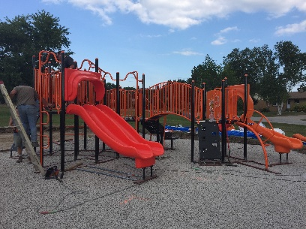

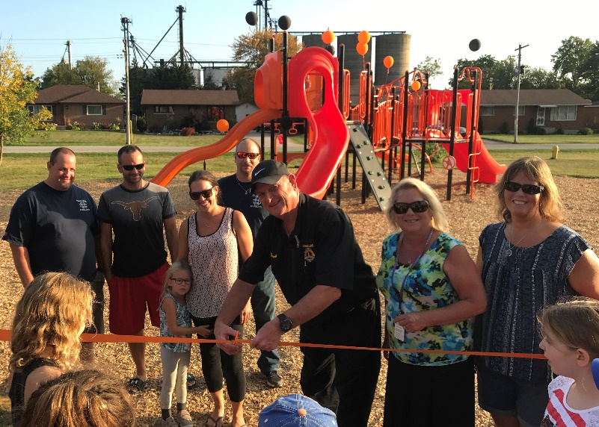

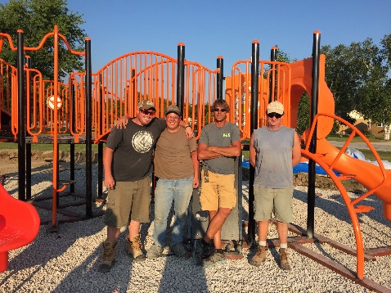

# 

Your interest in Courtland Public School and your continued support is appreciated. Please call Mrs. Stewart if you have any follow up questions or concerns regarding this newsletter.